# ICT 285

# Databases

# S2 2017

# Assignment 2

BY ANANTH KADEKODI (32920719)

**Account used for Assignment – V32920719**

**Table of Contents**

1. Part 1: Revised ERD and Schema Page 3
2. Part 2: Data Dictionary Page 5
3. Part 3: Implementation Page 12
4. Part 4: Views Page 22

**Part 1: Revised ERDN and Schema**

**A)**

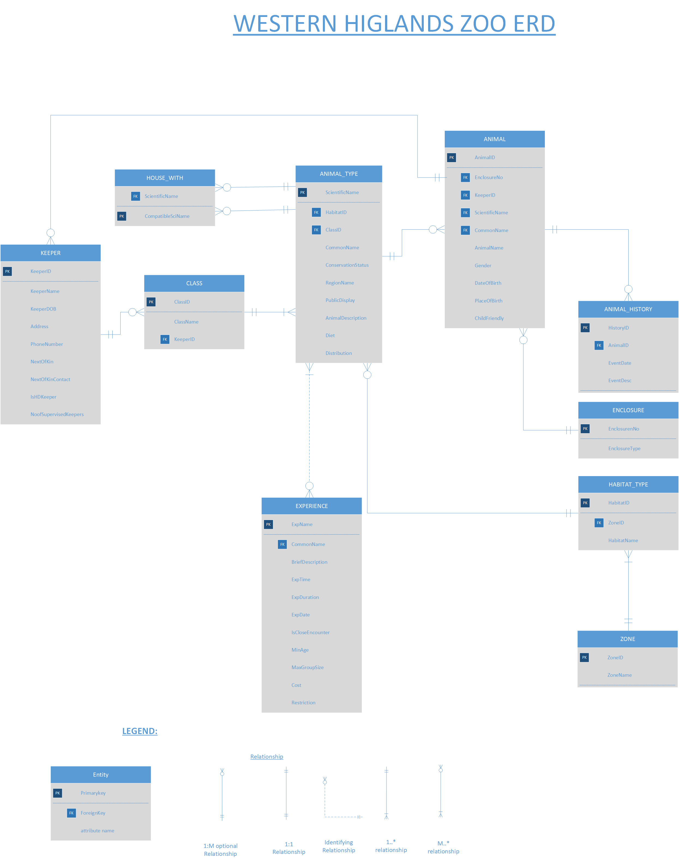

**B)**

A few changes were made to the ERD based on the new requirements from assignment 2 and feedback received from assignment 1. Some attributes from ANIMAL_TYPE were transferred to ANIMAL. This was mainly the Enclosure No and ChildFriendly. Additionally, a few attributes from ANIMAL were removed as they were not required for the ERD. These variables include – PublicDisplay. The primary key for ANIMAL and ANIMAL_TYPE were changed from IDCode and ClassType to ScientificName and AnimalID respectively. A lot of the attributes in the previous ERD had primary and foreign key (such as RegionArea, ConservationStatus and PublicDisplay). These were removed. Now the majority of the attributes are either Primary key or Foreign Key. Also, some of the specific entities such as Display were removed in this new ERD as they were quite irrelevant and not necessary to be implemented.

The primary key of the ANIMAL_TYPE was changed to ScientificName as the specific is identified by their Scientificname. Additionally, new entities were created regarding its class and conservation status. The individual animal was given a new Primary key known as AnimalID due to the individual animal being identified by its IDCode. The enclosure entity was previously linked to the ANIMAL_TYPE and this was changed to the ANIMAL. Additionally, the ANIMAL_TYPE now has recursive relationship to HOUSE_WITH as the animals can be housed with other animals of the same type or with other compatible types. An ANIMAL_HISTORY entity was created to store the notes regarding each animal. The HeadKeeper is now shown as a simple flag. Also in this situation, an assumption is being made that the class has more than one head keeper. Lastly, a new experience entity class has been created to meet with the requirements, of the Western Highlands Zoo. The details of the experiences are stored as attributes, within the Experience entity. Also, attributes of the close encounter experience are also stored within the Experience entity. It is flagged within the Experience entity. This means that if the experience is not close encounter then the attributes will be NULL.

**C)**

**Relational Schema in 3NF:**

* ANIMAL_TYPE(ScientificName**,** PublicDisplay, AnimalDescription, Diet, CommonName, Distribution**,** ConservationStatus,RegionName**, HabitatID, ClassID**) -
* ANIMAL(AnimalID**,** AnimalName, Gender, DateOfBirth, PlaceOfBirth, ChildFriendly **EnclosureNo, KeeperID, ScientificName, NotesDate**) -
* Keeper(KeeperID**,** KeeperName, KeeperDOB, Address, PhoneNumber, NextOfKin, NextOfKinContact, IsHDKeeper, NoofSupervisedKeepers) -
* HOUSE_WITH(CompatibleSciName**, ScientificName**) -
* Class(ClassID, ClassName, **KeeperID**) -
* EXPERIENCE(ExpName, BriefDescription, ExpTime, ExpDuration, ExpDate, IsCloseEncounter, MinAge, MaxGroupSize, Cost, Restriction, **CommonName**) -
* ANIMAL_HISTORY(HistoryID, EventDate, EventDesc, **AnimalID**) -
* ENCLOSURE(EnclosureNo, EnclosureType) -
* ZONE(ZoneID,ZoneName)
* HABITAT_TYPE(HabitatID, HabitatName, **ZoneID**)

**Part 2: Data Dictionary**

**ANIMAL_TYPE:**

|  |  |  |  |  |  |  |  |
| --- | --- | --- | --- | --- | --- | --- | --- |
| **Attribute Name** | **Description** | **Data type** | **Required** | **Allowable values** | **Unique** | **Key** | **Referential Integrity Rules (if applicable)** |
| ScientificName | Unique Identifier | VARCHARA2(50) | Yes | Valid scientific Name | Yes | Primary Key |  |
| CommonName | Animal Common Name | VARCHAR2(50) | Yes |  | Yes |  |  |
| RegionName | Region of the animal | VARCHAR2(50) | Yes | Europe and Asia, North America, Central and South America, Africa, Southeast Asia, Australia |  |  |  |
| Conservation Status | Conservation Status of the animal | VARCHAR2(50) | Yes | Critically Endangered, Endangered Vulnerable, Near Threatened, Least Concern, Unknown |  |  |  |
| PublicDisplay | Public Display of the animal | VARCHAR 2(50) | Yes | Yes/No |  |  |  |
| AnimalDescription | Description of the animal | VARCHAR2(1000) | Yes | Valid description |  |  |  |
| Diet | Diet of animal | VARCHAR2(50) |  | Any valid diet |  |  |  |
| Distribution | Distribution of the animal | VARCHAR2(50) |  | Valid distribution area |  |  |  |
| HabitatID | ID of the habitat that the animal stats in | NUMBER(3) | Yes | Valid zone name | Yes | Foreign Key | On delete cascade |
| ClassID | Class ID of the animal | NUMBER(3) | Yes | Valid classID | Yes | Foreign Key | On delete cascade |

**ANIMAL:**

|  |  |  |  |  |  |  |  |  |  |  |  |  |
| --- | --- | --- | --- | --- | --- | --- | --- | --- | --- | --- | --- | --- |
| **Attribute name** | | **Description** | **Data type** | **Required** | **Allowable values** | | | **Unique** | **Key** | | **Referential Integrity Rules (if applicable)** | |
| AnimalID | | Identification code of the animal | NUMBER(3) | Yes | Valid identification code | | |  | Primary Key | |  | |
| AnimalName | | Name of the animal | VARCHAR2(50) | Yes | Valid animal name | | |  |  | |  | |
| ScientificName | | ScientificName of the animal | VARCHAR2(50) | Yes | Valid scientific Name | | |  | Foreign Key | | On delete cascade | |
| CommonName | | CommonName of the animal | VARCHAR2(50) | Yes | Valid Common Name | | |  | Foreign key | | On delete cascade | |
| EnclosureNo | | Enclosure Number of the animal | NUMBER(3) | Yes | Valid enclosure No | | |  | Foreign Key | | On delete cascade | |
| KeeperID | | ID of the Keeper | NUMBER (3) | Yes | Valid Keeper ID | | |  | Foreign key | | On delete cascade | |
| DateOfBirth | | Date of birth of the animal | Date | Yes | Any valid date of birth | | |  |  | |  | |
| PlaceOfBirth | Place of birth of the animal | | VARCHAR2(50) | Yes | | Any valid place of birth |  | | |  | |  |
| Gender | Gender of the animal | | VARCHAR2(40) |  | | Male/Female |  | | | Foreign Key | | On delete cascade |
| ChildFriendly | Whether the animal is child friendly | | VARCHAR2(3) | Yes | | Yes/No |  | | |  | |  |

**HOUSE_WITH:**

|  |  |  |  |  |  |  |  |
| --- | --- | --- | --- | --- | --- | --- | --- |
| **Attribute Name** | **Description** | **Data Type** | **Required** | **Allowable values** | **Unique** | **Key** | **Referential Integrity Rules (if applicable)** |
| ScientificName | Scientific Name of the animal | VARCHAR2(50) | Yes | Valid scientific name |  | Foreign Key |  |
| CompatibleSciName | The compatible scientific name | VARCHAR2(50) | Yes | Valid compatible scientific name |  | Primary Key |  |
| Notes | Notes of compatibility | VARCHAR2(200) |  |  |  |  |  |

**KEEPER:**

|  |  |  |  |  |  |  |  |
| --- | --- | --- | --- | --- | --- | --- | --- |
| **Attribute name** | **Description** | **Data Type** | **Required** | **Allowable values** | **Unique** | **Key** | **Referential Integrity Rules (if applicable)** |
| KeeperID | The ID of the keeper | NUMBER(3) | Yes | Valid keeper ID |  | Primary Key |  |
| KeeperName | Name of the keeper | VARCHAR2(35) | Yes | Valid keeper name |  |  |  |
| KeeperDOB | The date of birth of the keeper | DATE | Yes | Any Valid date of birth |  |  |  |
| Address | The address of the keeper | VARCHAR2(100) | Yes | Any valid address |  |  |  |
| PhoneNumber | The phone number of the keeper | NUMBER(10) | Yes | Valid keeper phone number |  |  |  |
| NextOfKin | The next of kin of the keeper name | VARCHAR2(50) | Yes | Valid next of kin name |  |  |  |
| NextOfKinContact | The contact number of Keeper’s next of kin | NUMBER(10) | Yes | Valid phone number of keeper’s next of kin |  |  |  |
| IsHDKeeper | Details whether the keeper is the head | VARCHAR2(30) | Yes | Yes/No |  |  |  |
| NumberOfSupervisedKeepers | Number of keepers that the head keepr supervises | NUMBER(1) | Applicable only if the keeper is a head keeper | Valid number |  |  |  |

**ANIMAL_HISTORY:**

|  |  |  |  |  |  |  |  |
| --- | --- | --- | --- | --- | --- | --- | --- |
| **Attribute name** | **Description** | **Data Type** | **Required** | **Allowable values** | **Unique** | **Key** | **Referential Integrity Rules (if applicable)** |
| HistorYid | ID of the history recorded | NUMBER(4) | Yes | Valid ID Number |  | Primary Key |  |
| Animal ID | ID of the animal | NUMBER(3) | Yes | Valid animal ID noted |  | Foreign Key | On Delete Cascade |
| EventDate | Date that the event occurred | Date | Yes | Valid event date |  |  |  |
| EventDesc | Description of the event | VARCHAR2(100) | Yes | Valid Description of the event |  |  |  |

**ENCLOSURE:**

|  |  |  |  |  |  |  |  |
| --- | --- | --- | --- | --- | --- | --- | --- |
| **Attribute name** | **Description** | **Data Type** | **Required** | **Allowable values** | **Unique** | **Key** | **Referential Integrity Rules (if applicable)** |
| EnclosureNo | Each of the enclosure has an identification number | NUMBER(3) | Yes | Any valid positive integer |  | Primary Key | On delete no action, on update cascade |
| EnclosureType | The type of the enclosure. | VARCHAR2(50) | Yes | Valid enclosure type |  |  |  |

**CLASS:**

|  |  |  |  |  |  |  |  |
| --- | --- | --- | --- | --- | --- | --- | --- |
| **Attribute name** | **Description** | **Data Type** | **Required** | **Allowable values** | **Unique** | **Key** | **Referential Integrity Rules (if applicable)** |
| ClassID | The ID of the classes | NUMBER(3) | Yes | Any valid positive integer |  | Primary  Key |  |
| ClassName | The names of the class | VARCHAR2(20) |  | Mammals, reptiles, fish, amphibians, birds, invertebrates |  |  |  |
| KeeperID | The Identification code of the keeper | NUMBER(3) | Yes | Valid positive integer |  | Foreign Key | On delete cascade |

**Zone:**

|  |  |  |  |  |  |  |  |
| --- | --- | --- | --- | --- | --- | --- | --- |
| **Attribute name** | **Description** | **Data Type** | **Required** | **Allowable** | **Unique** | **Key** | **Referential Integrity Rules (if applicable)** |
| ZoneID | ID of the zone | NUMBER(3) | Yes | Valid number |  | Primary Key |  |
| ZoneName | Name of the zone | VARCHAR2(50) | Yes | Valid zone name |  |  |  |

**HABITAT_TYPE:**

|  |  |  |  |  |  |  |  |
| --- | --- | --- | --- | --- | --- | --- | --- |
| **Attribute name** | **Description** | **Data Type** | **Required** | **Allowable** | **Unique** | **Key** | **Referential Integrity Rules (if applicable)** |
| HabitatID | ID of the habitat | NUMBER(3) |  | Valid number |  | Primary Key |  |
| HabitatName | Name of the habitat | VARCHAR2(50) |  | Valid habitat name |  |  |  |
| ZoneID | ID of the zone | NUMBER (3) |  | Valid zone ID |  | Foreign Key | On Delete Cascade |

**EXPERIENCE:**

|  |  |  |  |  |  |  |  |
| --- | --- | --- | --- | --- | --- | --- | --- |
| **Attribute name** | **Description** | **Data Type** | **Required** | **Allowable** | **Unique** | **Key** | **Referential Integrity Rules (if applicable)** |
| ExpName | The name of the experience | VARCHAR2(50) | Yes | Any Valid name |  | Primary Key |  |
| CommonName | Common name of the animal | VARCHAR2(50) |  | Valid common name |  |  |  |
| BriefDescription | A brief description of the experience | VARCHAR2(200) | Yes | Any Valid description |  |  |  |
| ExpTime | The time that the experience is held | VARCHAR2(20) | Yes | Any valid experience time before zoo closure |  |  |  |
| ExpDuration | The duration of the experience | NUMBER(1) | Yes | Any valid positive integer equal. Max equal to zoo’s working hour. Thi s is usually 8 hours. |  |  |  |
| MinAge | The min age for close encounter experience | NUMBER(1) |  | Only filled if encounter is close. Positive integer. |  |  |  |
| ExpDate | Date of the experience | DATE | Yes | Valid Experience Date |  |  |  |
| MaxGroupSize | The max group size for close encounter experience | NUMBER(3) |  | Positive group size > 0 (if close encounter) else NULL |  |  |  |
| Cost | The cost of close encounter experience | NUMBER (4,2) |  | Any Positive cost (If close encounter) else NULL. Has to be more than 0 |  |  |  |
| Restriction | The restriction for close encounter experience | VARCHAR2(100) |  | Valid restriction (Only if close encounter) else NULL |  |  |  |
| IsCloseEncounter | Whether the experience is a close encounter experience | VARCHAR2(20) | Yes | Yes or No |  |  |  |

**Business rules and Enterprise Constraints:**

* The experience time should be within the working hours of zoo
* The experience duration should not be too long (like 8 hours). A reasonable time should exist
* The minimum age and maximum group size should be more than 0
* The experiences have more than 0 animals.
* The animal notes ‘date’ cannot be earlier than the date of birth
* The animal’s display time must be within the operating hours of the zoo
* The experience must have at least a single guide
* The location of the event should be provided.
* If the event does not have a duration, then only the start time should be present.

**PART 3: Implementation :**

**V Account Used – V32920719**

**Insert Functions:**

**Zone:**

INSERT INTO ZONE VALUES('Australian Bushland', '111');

INSERT INTO ZONE VALUES('Savannah', '112');

INSERT INTO ZONE VALUES('Rainforest', '113');

INSERT INTO ZONE VALUES('Grasslands', '114');

INSERT INTO ZONE VALUES('Rivers', '115');

INSERT INTO ZONE VALUES('Ponds', '116');

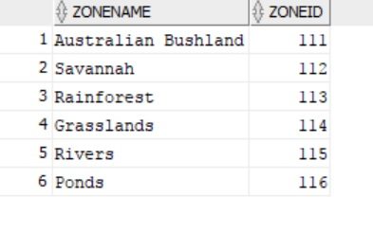

**Habitat _Type:**

INSERT INTO HABITAT_TYPE VALUES ('111', 'Beech Wood', '111');

INSERT INTO HABITAT_TYPE VALUES ('112', 'Broadleaf Forest', '111');

INSERT INTO HABITAT_TYPE VALUES ('113', 'Brownfield Land', '111');

INSERT INTO HABITAT_TYPE VALUES ('114', 'Chalk Grassland', '112');

INSERT INTO HABITAT_TYPE VALUES ('115', 'Coastal', '112');

INSERT INTO HABITAT_TYPE VALUES ('116', 'Coniferous Forest', '113');

INSERT INTO HABITAT_TYPE VALUES ('117', 'Desert', '113');

INSERT INTO HABITAT_TYPE VALUES ('118', 'Farmland', '114');

INSERT INTO HABITAT_TYPE VALUES ('119', 'Flooded Grassland', '114');

INSERT INTO HABITAT_TYPE VALUES ('120', 'Heathland', '115');

INSERT INTO HABITAT_TYPE VALUES ('121', 'Hedgerows', '115');

INSERT INTO HABITAT_TYPE VALUES ('122', 'Mangroves', '116');

INSERT INTO HABITAT_TYPE VALUES ('123', 'Mediterranean Forest', '116')

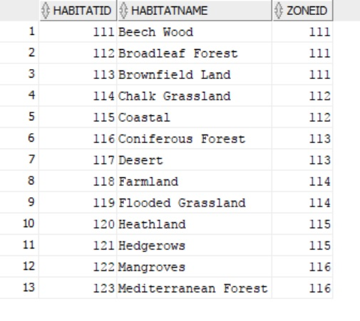

**Class:**

INSERT INTO CLASS VALUES ('100', 'mammals', '100');

INSERT INTO CLASS VALUES ('101', 'reptiles', '101');

INSERT INTO CLASS VALUES ('102', 'fish', '102');

INSERT INTO CLASS VALUES ('103', 'amphibians', '103');

INSERT INTO CLASS VALUES ('104', 'birds', '104');

INSERT INTO CLASS VALUES ('105', 'invertebrates', '105');

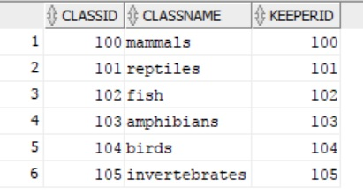

**Enclosure:**

INSERT INTO ENCLOSURE VALUES ('200', 'Savannah');

INSERT INTO ENCLOSURE VALUES ('201', 'Rainforest');

INSERT INTO ENCLOSURE VALUES ('202', 'Topical Rainforest');

INSERT INTO ENCLOSURE VALUES ('203', 'Open grassland');

INSERT INTO ENCLOSURE VALUES ('204', 'Rivers and Creeks');

INSERT INTO ENCLOSURE VALUES ('205', 'Woodland');

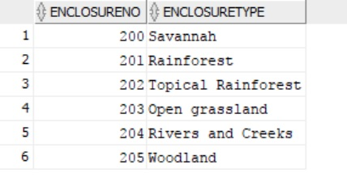

**Keeper:**

INSERT INTO KEEPER VALUES ('100', 'Elliot Langley', to_date('1970-12-15', 'YYYY-MM-DD'), '7500 Pippin, San Francisco, California, United States, 8500', '0435174569', 'John Smith', '0359823908', 'NO', '0');

INSERT INTO KEEPER VALUES ('101', 'Kyle Rogers', to_date('1970-10-15', 'YYYY-MM-DD'), '7500 Bedford, San Francisco, California, United States, 8500', '0435177865', 'Jason Bob', '9375639207', 'NO', '0');

INSERT INTO KEEPER VALUES ('102', 'Ajay Sharma', to_date('1965-08-13', 'YYYY-MM-DD'), '800 Sunset, San Diego, California, United States, 8500', '0435137901', 'Jason Bourne', '0359123908', 'NO', '0');

INSERT INTO KEEPER VALUES ('103', 'Joe Chance', to_date('1967-08-13', 'YYYY-MM-DD'), '815 Sunnyvale, Seattle, Washington, United States, 5500', '0435189460', 'Jack Lee', '0359126743', 'YES', '3');

INSERT INTO KEEPER VALUES ('104', 'Jason Tan', to_date('1969-03-05', 'YYYY-MM-DD'), '515 Fremont, San Francisco, California, United States, 8500', '0435187825', 'Fiona Lo', '0359906525', 'YES', '2');

INSERT INTO KEEPER VALUES ('105', 'Kevin Song', to_date('1950-01-05', 'YYYY-MM-DD'), '200 Long Beach, Los Angeles, California, United States, 8560', '0435190466', 'Josh Yoon', '5678326743', 'NO', '0');

INSERT INTO KEEPER VALUES ('106', 'Jonathan Smith', to_date('1975-03-03', 'YYYY-MM-DD'), '400 Compton, Los Angeles, California, United States, 8560', '0984689460', 'Chris Smith', '9654126743', 'NO','0');

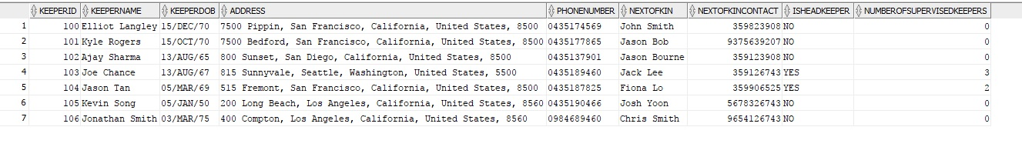

**Animal_Type:**

INSERT INTO ANIMAL_TYPE VALUES (‘Elephas Maximus’, ‘Asian Elephant’, ‘Southeast Asia’, ‘Endangered’, ‘ Yes’, ‘The Asian Elephant is smaller than the African Elephant. The elephants use their trunks to pull down tree brances and eat the leaves. Compared to the African Elephant, they have a smoother and darker skin ‘, ‘Plants, grass and leaves’, ‘India, Srilanka, Burma, Indonesia’, ‘114’, ‘100’);

INSERT INTO ANIMAL_TYPE VALUES ('Giraffa camelopardalis', 'Giraffe', 'Africa', 'Endangered', 'Yes', 'The girafee is notable for having a very tall neck. This allows it to look for predators at the distance and eat leaves from high trees. ', 'Plants, grass and leaves', 'Central Africa', '114', '100');

INSERT INTO ANIMAL_TYPE VALUES ('Crocodylus Johnstoni', 'Freshwater Crocodile', 'Australia', 'Least Concern', 'Yes', 'The freshwater crocodiles are brown to olive in colour. They have a leathery hide and a long narrow snout for eating food. Their skin is extremely hard and protects them from predators', 'Frogs, fish, turtles, reptiles, waterbirds', 'Australia mainly located to NT and Nothern WA', '119', '101');

INSERT INTO ANIMAL_TYPE VALUES ('Dromaius novaehollandiae', 'Emu', 'Australia', 'Least Concern', 'Yes', 'The EMU is a black bird, that cannot fly. It has string powerful legs and can run at least 50lm/h. They have blusih skin on their face', 'Omnivores and eat a variety of plants and insects', 'Throughout Australia', '111', '104');

INSERT INTO ANIMAL_TYPE VALUES ('Hyla Arborea', 'European Tree Frog', 'Europe and Asia', 'Least Concern', 'Yes', 'The frogs dorsal skin is smooth and their ventral skin is granular. The dorsal skin can be green, gray or tan depending on the weather condition', 'They eat a variety of insects', 'Throughout Europe', '116’, '103');

INSERT INTO ANIMAL_TYPE VALUES ('Siluriformes', 'Catfish', 'Europe and Asia', 'Least Concern', 'Yes', ‘The catfish are a diverse group of ray-finned fish. They are named for their prominent barnels, resembling a cat whiskers. They range in size and behaviour’ , 'Omnivores and eat a variety of plants and insects', 'Throughout the world', '118', '102')

INSERT INTO ANIMAL_TYPE VALUES ('Asteroidea', 'Starfish', 'Central and South America', 'Least Concern', 'Yes', 'The starfish is a star shaped animal of the sea. They are thick and spiky. But generally very harmless', 'They eat a variety of insects', 'Throughout the world', '122', '105');

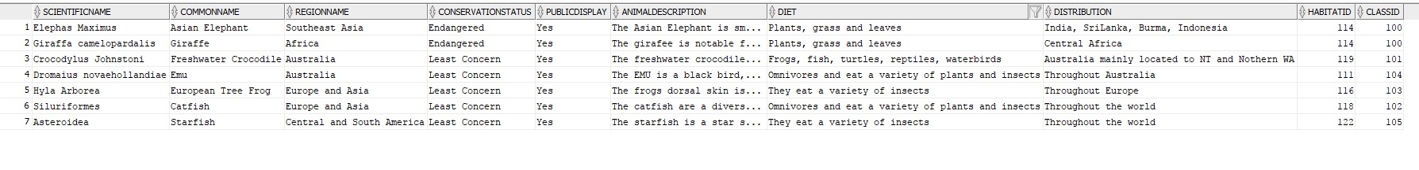

**Animal:**

INSERT INTO ANIMAL VALUES ('100', 'John', 'Elephas Maximus', 'Asian Elephant', '201', '101', to_date('10-11-2011', 'DD-MM-YYYY'), 'Western Highland Zoo', 'Male', 'YES');

INSERT INTO ANIMAL VALUES ('101', 'Sandy', 'Elephas Maximus', 'Asian Elephant', '201', '101', to_date('25-04-2013', 'DD-MM-YYYY'), 'Western Highland Zoo', 'Female', 'YES');

INSERT INTO ANIMAL VALUES ('102', 'Jacob', 'Elephas Maximus', 'Asian Elephant', '201', '101', to_date('25-04-2013', 'DD-MM-YYYY'), 'Western Highland Zoo', 'Male', 'YES');

INSERT INTO ANIMAL VALUES ('103', 'Sophie', 'Giraffa camelopardalis', 'Giraffe', '203', '103', to_date('25-01-2016', 'DD-MM-YYYY'), 'Western Highland Zoo', 'Female', 'YES');

INSERT INTO ANIMAL VALUES ('104', 'Ben', 'Elephas Maximus', 'Giraffe', '203', '103', to_date('30-03-2014', 'DD-MM-YYYY'), 'Western Highland Zoo', 'Male', 'YES');

INSERT INTO ANIMAL VALUES ('105', 'Jonathan', 'Crocodylus Johnstoni', 'Freshwater Crocodile', '204', '102', to_date('20-09-2012', 'DD-MM-YYYY'), 'Western Highland Zoo', 'Male', 'YES');

INSERT INTO ANIMAL VALUES ('106', 'Sara', 'Crocodylus Johnstoni', 'Freshwater Crocodile', '204', '102', to_date('13-07-2013', 'DD-MM-YYYY'), 'Western Highland Zoo', 'Female', 'YES');

INSERT INTO ANIMAL VALUES ('107', 'Sam', 'Dromaius novaehollandiae', 'Emu', '205', '102', to_date('25-02-2014', 'DD-MM-YYYY'), 'Western Highland Zoo', 'Male', 'YES');

INSERT INTO ANIMAL VALUES ('108', 'Amy', 'Dromaius novaehollandiae', 'Emu', '205', '102', to_date('13-12-2011', 'DD-MM-YYYY'), 'Western Highland Zoo', 'Female', 'YES');

INSERT INTO ANIMAL VALUES ('109', 'Elizabeth', 'Hyla Arborea', 'Emu', '204', '105', to_date('26-10-2012', 'DD-MM-YYYY'), 'Western Highland Zoo', 'Female', 'YES');

INSERT INTO ANIMAL VALUES ('110', 'Jack', 'Hyla Arborea', 'Emu', '204', '105', to_date('10-05-2012', 'DD-MM-YYYY'), 'Western Highland Zoo', 'Male', 'YES');

INSERT INTO ANIMAL VALUES ('111', 'Will', 'Siluriformes', 'Catfish', '203', '106', to_date('19-02-2012', 'DD-MM-YYYY'), 'Western Highland Zoo', 'Male', 'YES');

INSERT INTO ANIMAL VALUES ('112', 'Jason', 'Siluriformes', 'Catfish', '203', '106', to_date('23-08-2012', 'DD-MM-YYYY'), 'Western Highland Zoo', 'Male', 'YES');

INSERT INTO ANIMAL VALUES ('113', 'Josh', 'Asteroidea', 'Starfish', '202', '101', to_date('29-11-2009', 'DD-MM-YYYY'), 'Western Highland Zoo', 'Male', 'YES');

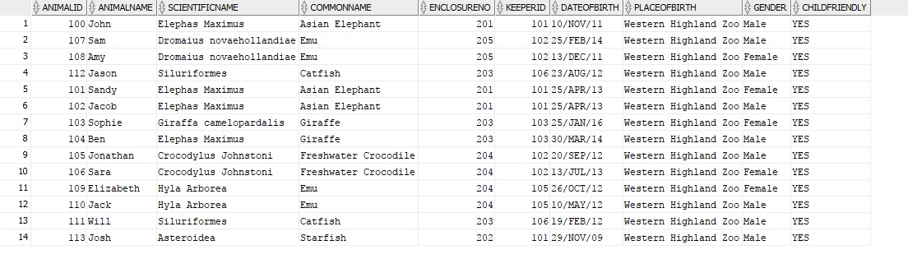

**Animal_History:**

INSERT INTO ANIMAL_HISTORY VALUES ('1000', '103', to_date('25-01-2016','DD-MM-YYYY'), 'No Complication at birth for Sophie the giraffe');

INSERT INTO ANIMAL_HISTORY VALUES ('1001', '103', to_date('18-03-2016','DD-MM-YYYY'), 'Vaccination given to Sophie');

INSERT INTO ANIMAL_HISTORY VALUES ('1002', '103', to_date('06-05-2016','DD-MM-YYYY'), 'Routine checkup was provided to sophie');

INSERT INTO ANIMAL_HISTORY VALUES ('1003', '103', to_date('21-08-2016','DD-MM-YYYY'), 'Broken left leg injury. Treated with bandages ');

INSERT INTO ANIMAL_HISTORY VALUES ('1004', '103', to_date('28-12-2016','DD-MM-YYYY'), 'Routine checkup completed - No abnormality');

INSERT INTO ANIMAL_HISTORY VALUES ('1005', '100', to_date('10-11-2011','DD-MM-YYYY'), 'Routine checkup completed - No abnormality for John');

INSERT INTO ANIMAL_HISTORY VALUES ('1006', '101', to_date('25-04-2013','DD-MM-YYYY'), 'Routine checkup completed - No abnormality for Sandy');

INSERT INTO ANIMAL_HISTORY VALUES ('1007', '102', to_date('25-04-2011','DD-MM-YYYY'), 'Routine checkup completed - No abnormality for Jacob');

INSERT INTO ANIMAL_HISTORY VALUES ('1008', '104', to_date('30-03-2014','DD-MM-YYYY'), 'Routine checkup completed - No abnormality for Ben');

INSERT INTO ANIMAL_HISTORY VALUES ('1009', '105', to_date('20-09-2012','DD-MM-YYYY'), 'Routine checkup completed - No abnormality for Jonathan');

INSERT INTO ANIMAL_HISTORY VALUES ('1010', '106', to_date('13-07-2013','DD-MM-YYYY'), 'Routine checkup completed - No abnormality for Sara');

INSERT INTO ANIMAL_HISTORY VALUES ('1011', '107', to_date('25-02-2014','DD-MM-YYYY'), 'Routine checkup completed - No abnormality for Sam');

INSERT INTO ANIMAL_HISTORY VALUES ('1012', '108', to_date('13-12-2011','DD-MM-YYYY'), 'Routine checkup completed - No abnormality for Amy');

INSERT INTO ANIMAL_HISTORY VALUES ('1013', '109', to_date('26-10-2012','DD-MM-YYYY'), 'Routine checkup completed - No abnormality for Elizabeth');

INSERT INTO ANIMAL_HISTORY VALUES ('1014', '110', to_date('10-05-2011','DD-MM-YYYY'), 'Routine checkup completed - No abnormality for Jack');

INSERT INTO ANIMAL_HISTORY VALUES ('1015', '111', to_date('19-02-2012','DD-MM-YYYY'), 'Routine checkup completed - No abnormality for WIll');

INSERT INTO ANIMAL_HISTORY VALUES ('1016', '112', to_date('23-08-2012','DD-MM-YYYY'), 'Routine checkup completed - No abnormality for Jason');

INSERT INTO ANIMAL_HISTORY VALUES ('1017', '113', to_date('29-11-2009','DD-MM-YYYY'), 'Routine checkup completed - No abnormality for Josh');

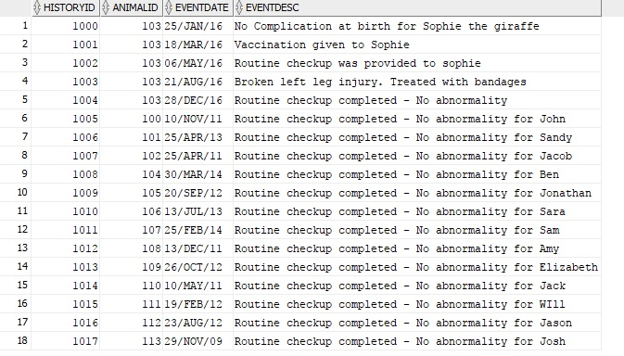

**House_With:**

INSERT INTO HOUSE_WITH VALUES('Giraffa camelopardalis', 'Elephas Maximus', 'The giraffe and elephant live in harmony together');

INSERT INTO HOUSE_WITH VALUES('Giraffa camelopardalis', 'Dromaius novaehollandiae', 'The giraffe and emu live in harmony together');

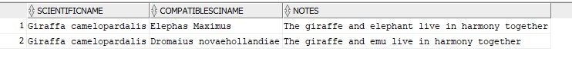

**Experience:**

INSERT INTO EXPERIENCE VALUES ('Giraffe show', 'Giraffe', 'Meet a giraffe up close and learn from experts about their life', '10:00', '2', '', to_date('5-11-2017','DD-MM-YYYY'), '', '', '', 'NO');

INSERT INTO EXPERIENCE VALUES ('Elephant show', 'Asian Elephant', 'Meet an elephant up close and learn from experts about their life', '12:00', '1', '', to_date('2-11-2017','DD-MM-YYYY'), '', '', '', 'NO');

INSERT INTO EXPERIENCE VALUES ('Elephant show Returns', 'Asian Elephant', 'Meet an elephant up close and learn from experts about their life', '14:00', '1', '', to_date('4-11-2017','DD-MM-YYYY'), '', '', '', 'NO');

INSERT INTO EXPERIENCE VALUES ('Crocodile show', 'Freshwater Crocodile', 'Meet a crocodile up close and learn from experts about their life', '13:00', '2', '8', to_date('5-11-2017','DD-MM-YYYY'), '100', '5.00', 'Full close shows requried for the event', 'YES');

INSERT INTO EXPERIENCE VALUES ('The EMU Show', 'Emu', 'Meet an EMU up close and learn from experts about their life', '15:00', '2', '8', to_date('5-11-2017','DD-MM-YYYY'), '100', '5.00', 'Full close shows requried for the event', 'YES');

INSERT INTO EXPERIENCE VALUES ('The Frog Show', 'European Tree Frog', 'Meet an European Tree Frog up close and learn from experts about their life', '15:00', '2', '8', to_date('1-11-2017','DD-MM-YYYY'), '100', '5.00', 'Full close shows requried for the event', 'YES');

INSERT INTO EXPERIENCE VALUES ('Catfish show', 'Catfish', 'Observe catfish up close and learn from experts about their life', '09:00', '1', '', to_date('1-11-2017','DD-MM-YYYY'), '', '', '', 'NO');



**Grant functions:**

GRANT Select, update, insert, delete

on ANIMAL

to MARKERTL;

GRANT Select, update, insert, delete

on ANIMAL_HISTORY

to MARKERTL;

GRANT Select, update, insert, delete

on ANIMAL_TYPE

to MARKERTL;

GRANT Select, update, insert, delete

on CLASS

to MARKERTL;

GRANT Select, update, insert, delete

on EXPERIENCE

to MARKERTL;

GRANT Select, update, insert, delete

on ENCLOSURE

to MARKERTL;

GRANT Select, update, insert, delete

on HOUSE_WITH

to MARKERTL;

GRANT Select, update, insert, delete

on KEEPER

to MARKERTL;

GRANT Select, update, insert, delete

on ZONE

to MARKERTL;

GRANT Select, update, insert, delete

on HABITAT_TYPE

to MARKERTL;

GRANT Select, update, insert, delete

on VIEWA

to MARKERTL;

GRANT Select, update, insert, delete

on VIEWB

to MARKERTL;

GRANT Select, update, insert, delete

on VIEWC

to MARKERTL;

GRANT Select, update, insert, delete

on VIEWD

to MARKERTL;

GRANT Select, update, insert, delete

on VIEWE

to MARKERTL;

GRANT Select, update, insert, delete

on VIEWF

to MARKERTL;

GRANT Select, update, insert, delete

on VIEWG

to MARKERTL;

GRANT Select, update, insert, delete

on VIEWH

to MARKERTL;

GRANT Select, update, insert, delete

on VIEWI

to MARKERTL;

GRANT Select, update, insert, delete

on VIEWJ

to MARKERTL;

**PART 4: Views**

**View A**

CREATE view ViewA as

SELECT SCIENTIFICNAME, COMMONNAME, CLASSNAME, CONSERVATIONSTATUS

FROM ANIMAL_TYPE A, CLASS C

WHERE A.CLASSID = C.CLASSID;

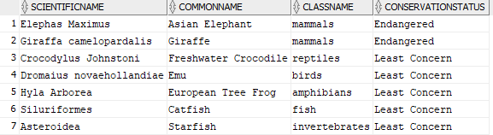

**View B:**

CREATE VIEW ViewB AS

SELECT ScientificName, COUNT(*) AS Total

FROM ANIMAL

GROUP BY ScientificName

ORDER BY COUNT(*) DESC;

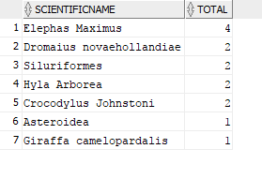

**View C:**

CREATE view ViewC as

SELECT ScientificName, CommonName, ConservationStatus

FROM ANIMAL_TYPE A

WHERE A.ConservationStatus = 'Endangered';

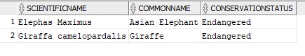

**View D:**

CREATE VIEW ViewD AS

SELECT KEEPER.KeeperID, KEEPER.KeeperName, Animal.AnimalID, Animal.AnimalName, Animal.CommonName, Enclosure.EnclosureNo, Enclosure.EnclosureType

FROM (KEEPER JOIN ANIMAL ON KEEPER.KeeperID = ANIMAL.KeeperID)

JOIN ENCLOSURE ON (ANIMAL.EnclosureNo = ENCLOSURE.EnclosureNo)

WHERE Keeper.KeeperName = 'Kyle Rogers';

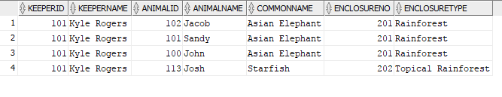

**View E:**

CREATE VIEW ViewE AS

SELECT KeeperID, KeeperName, NumberOfSupervisedKeepers

FROM KEEPER K

WHERE K.IsHeadKeeper = 'YES';

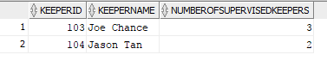

**View F:**

CREATE view ViewF AS

SELECT ZoneName, ScientificName, CommonName

FROM (ANIMAL_TYPE JOIN HABITAT_TYPE ON ANIMAL_TYPE.HabitatID = HABITAT_TYPE.HabitatID)

JOIN ZONE ON HABITAT_TYPE.ZoneID = ZONE.ZoneID

WHERE ZONE.ZoneName = 'Savannah';

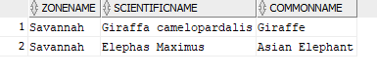

**View G:**

CREATE VIEW ViewG AS

SELECT distinct KeeperName, ZoneName

FROM (((KEEPER JOIN ANIMAL

ON KEEPER.KeeperID = ANIMAL.KeeperID) JOIN ANIMAL_TYPE

ON ANIMAL_TYPE.ScientificName = Animal_Type.ScientificName) JOIN HABITAT_TYPE

ON ANIMAL_TYPE.HabitatID = HABITAT_TYPE.HabitatID) JOIN ZONE

ON HABITAT_TYPE.ZoneID = ZONE.ZoneID

WHERE ZONE.ZoneName = 'Rainforest';

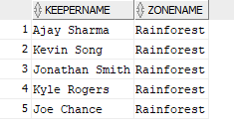

**View H:**

CREATE view ViewH AS

SELECT AH.HistoryID, A.AnimalID, A.AnimalName, AH.EventDate, AH.EventDesc

FROM ANIMAL A, ANIMAL_HISTORY AH

WHERE A.AnimalID = AH.AnimalID

and A.AnimalName = 'Sophie'

and AH.EventDate LIKE '%16';

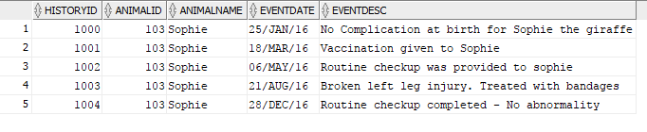

**View I:**

CREATE VIEW ViewI AS

SELECT ExpName, BriefDescription, ExpTime, ExpDuration, ExpDate

FROM EXPERIENCE E

WHERE E.ExpDate = '05/NOV/17'

ORDER BY E.ExpTime ASC;

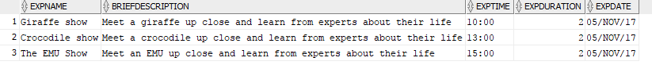

**View J:**

Create VIEW ViewJ AS

SELECT ExpName, BriefDescription, ExpTime, ExpDuration, ExpDate

FROM EXPERIENCE E

WHERE E.CommonName = 'Asian Elephant'

and E.ExpDate between '01/NOV/17' and '7/NOV/17';

C:\Users\Ananth\Documents\Murdoch\ICT285\iMAGES\20.png